31.18: a)

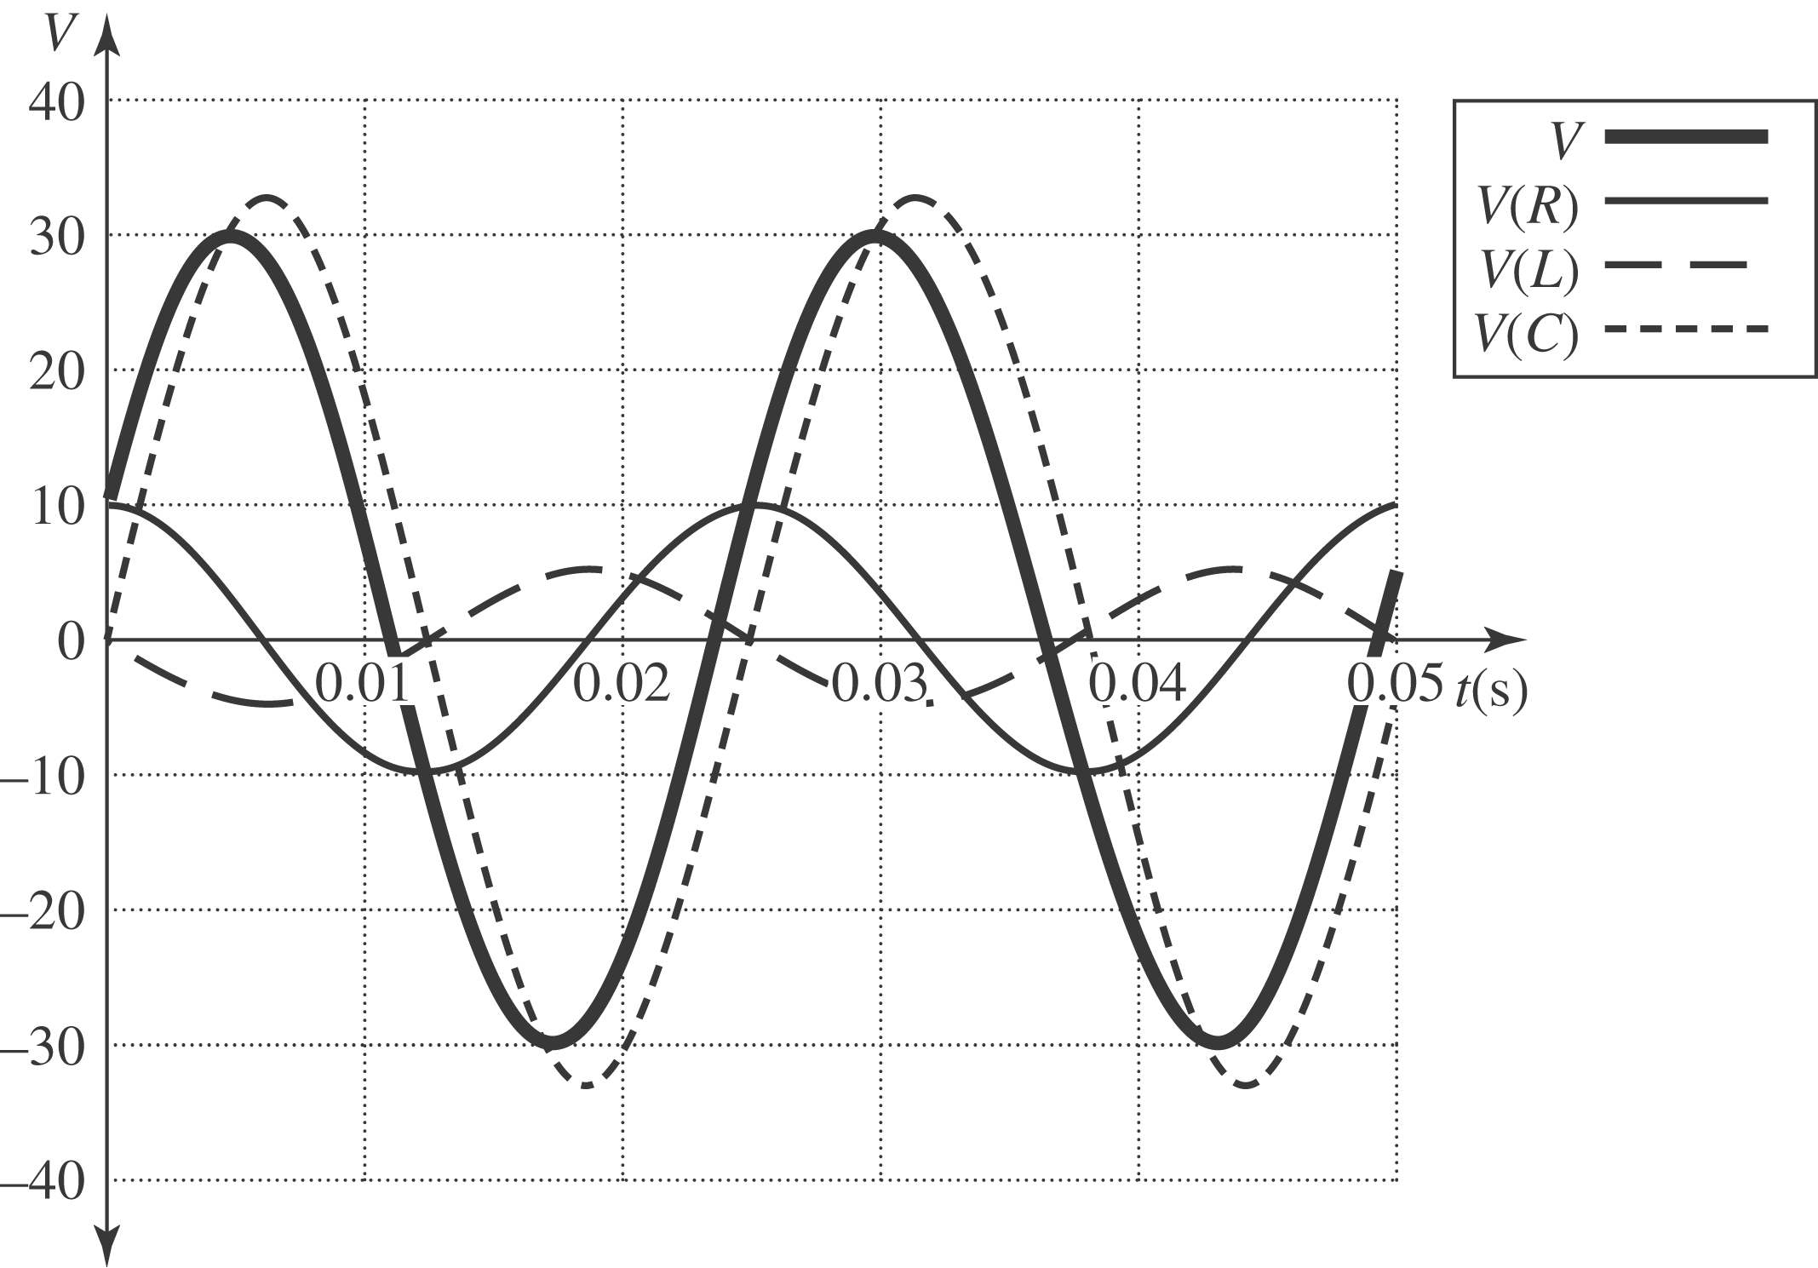

The different voltages plotted above are:
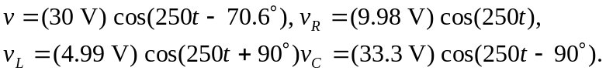
b)
c)
In both parts (b) and (c), note that the voltage equals the sum of the other voltages at the given instant. Be careful with degrees vs. radians!

